Setting Configs and Environments

* Source Dataset – SQL Server Database Tables
* Target Sink - Azure Blob Storage Container (Parquets)
* Transformation Intermediaries – Azure Databricks

1. Source SQL Server with Parameters

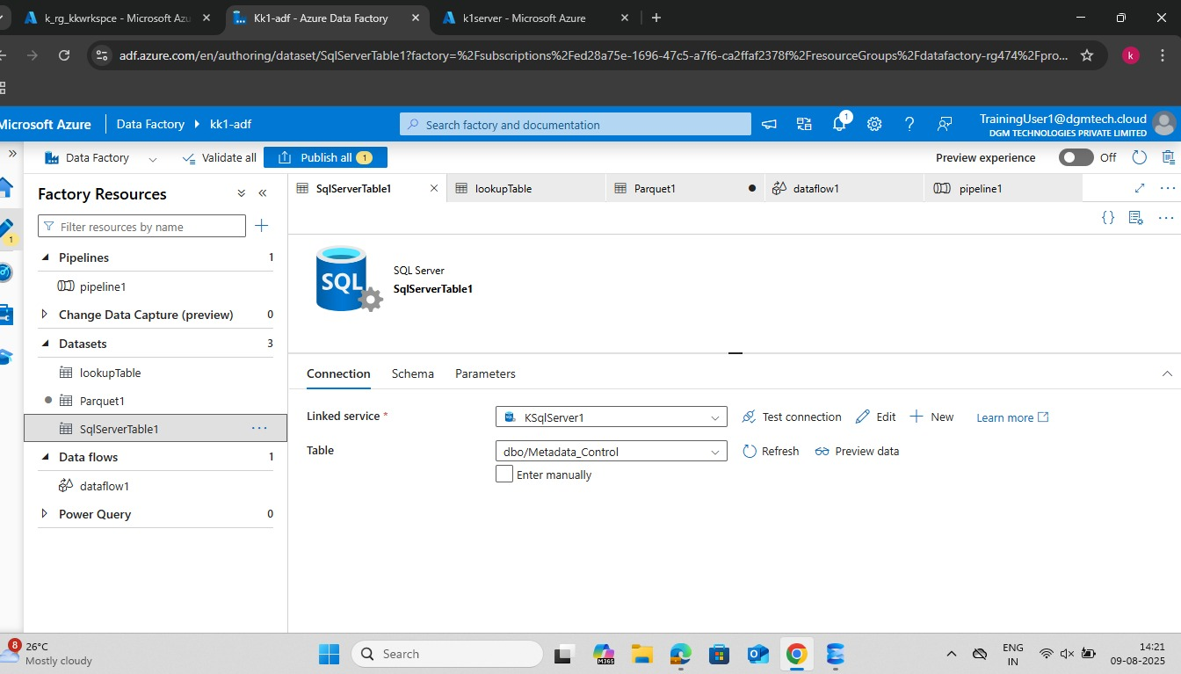

1. SQL Server (Lookup Table) w/o Params

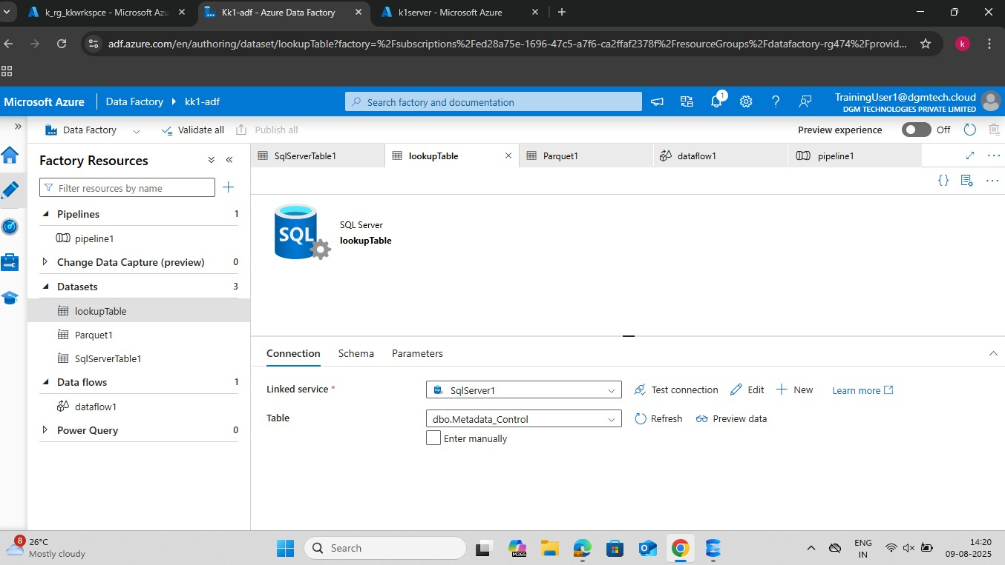

1. Data Sink Storage

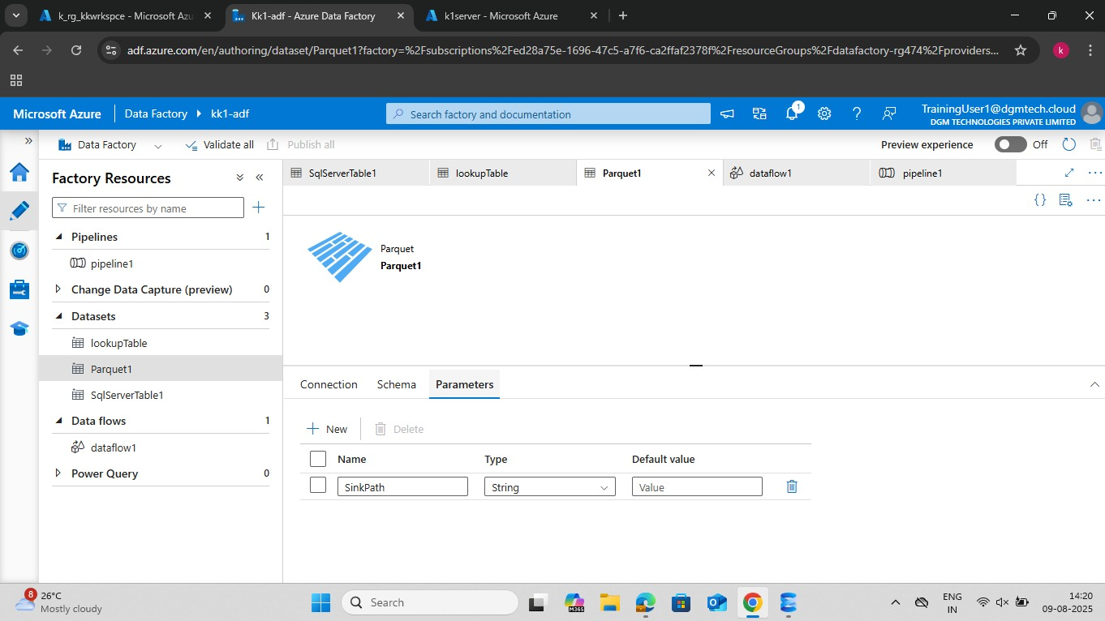

1. Data Flow Structure

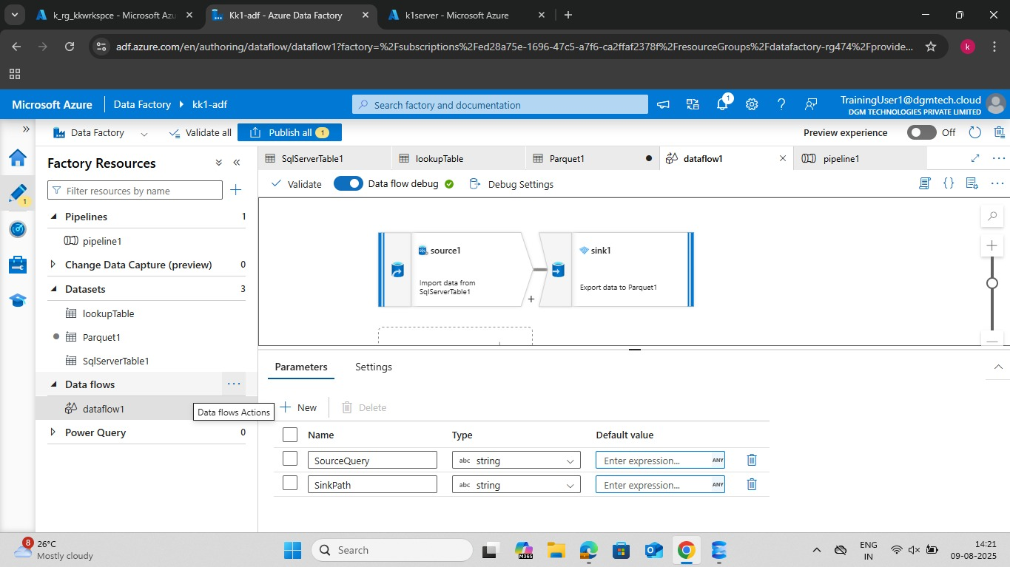

1. Data Flow Structure (Source)

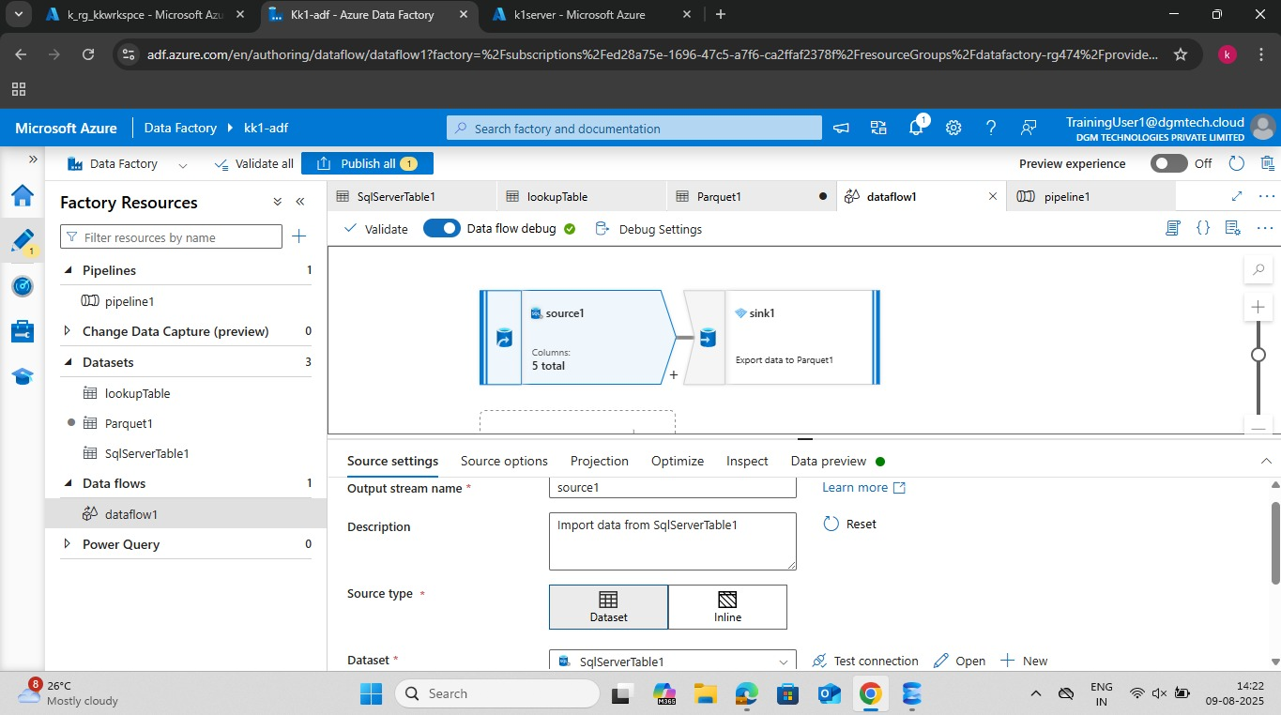

1. Data Flow Structure (Sink)

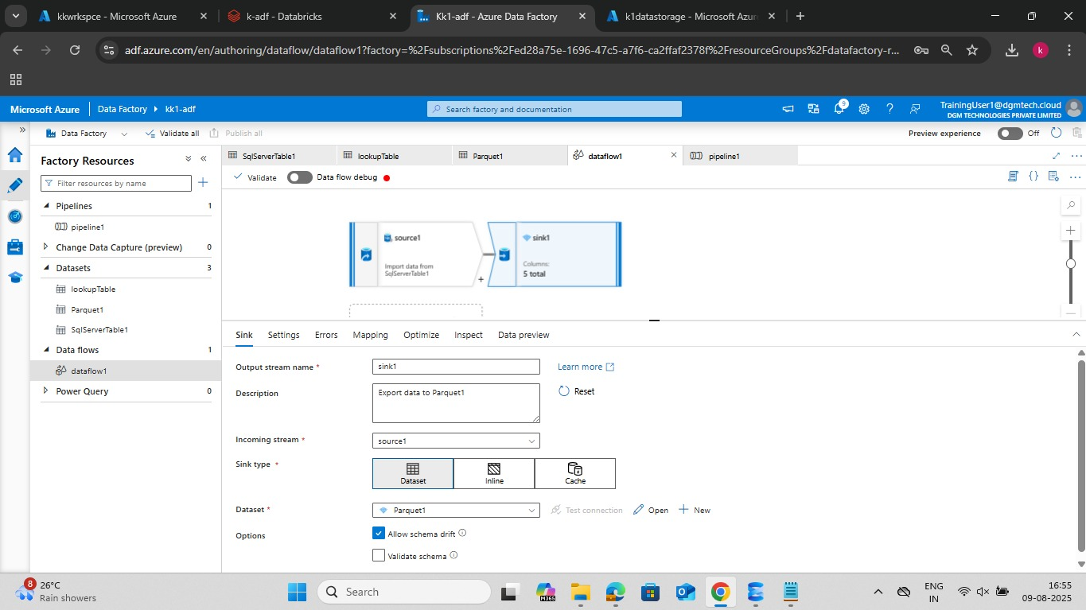

1. Linked Services

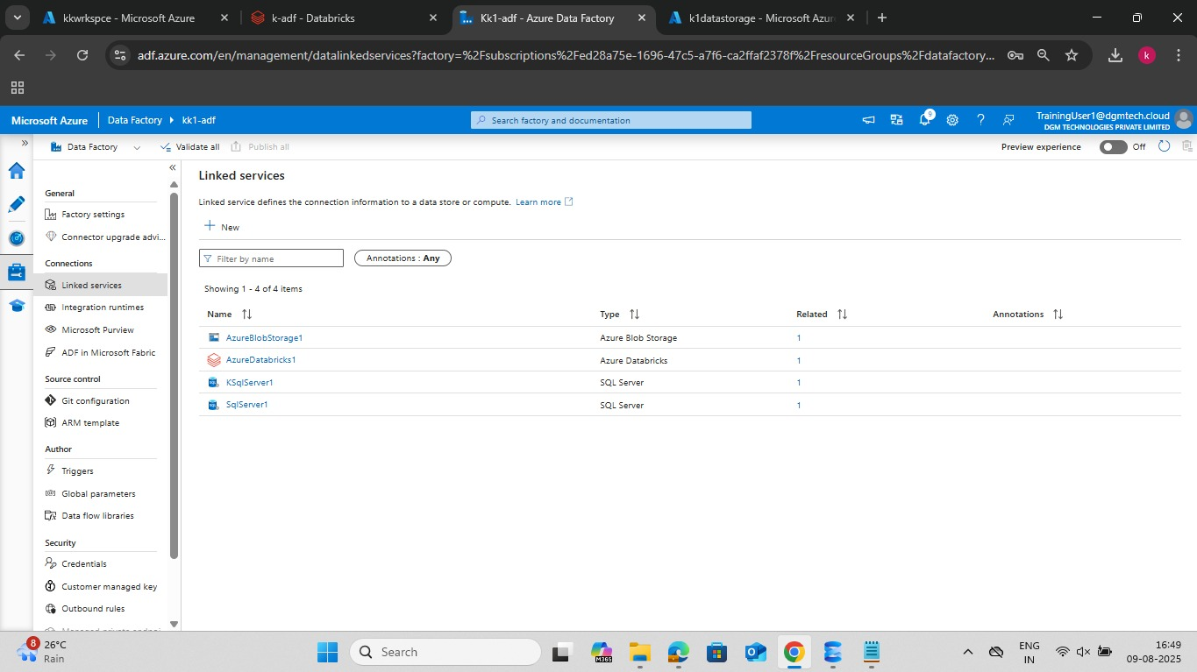

1. Pipeline Structure and Success

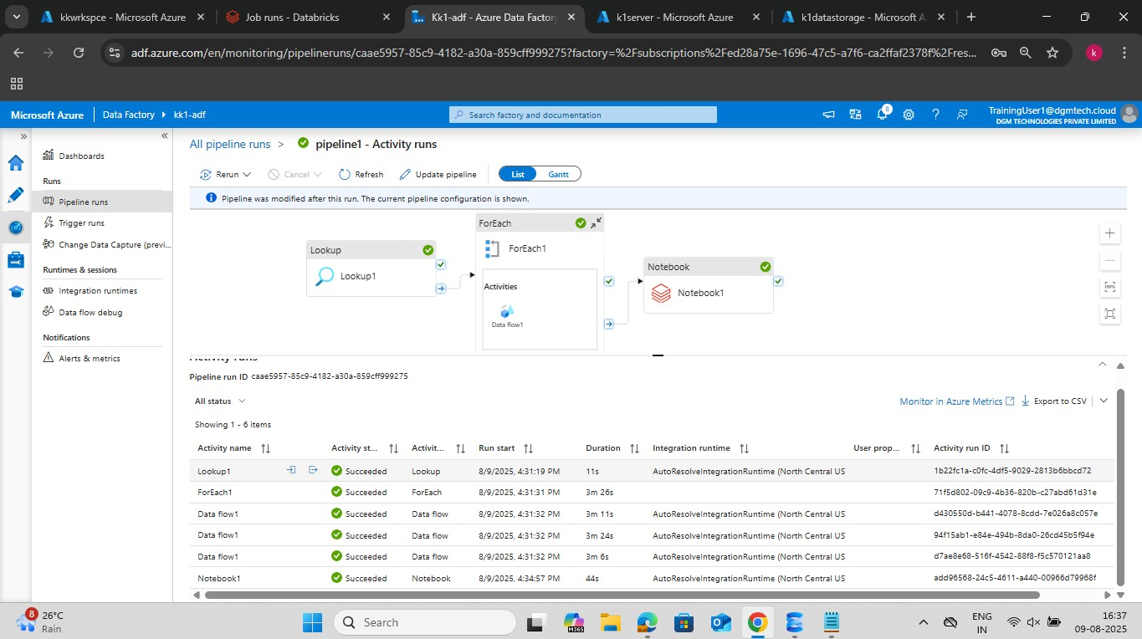

1. Databricks Transformations and Job Run

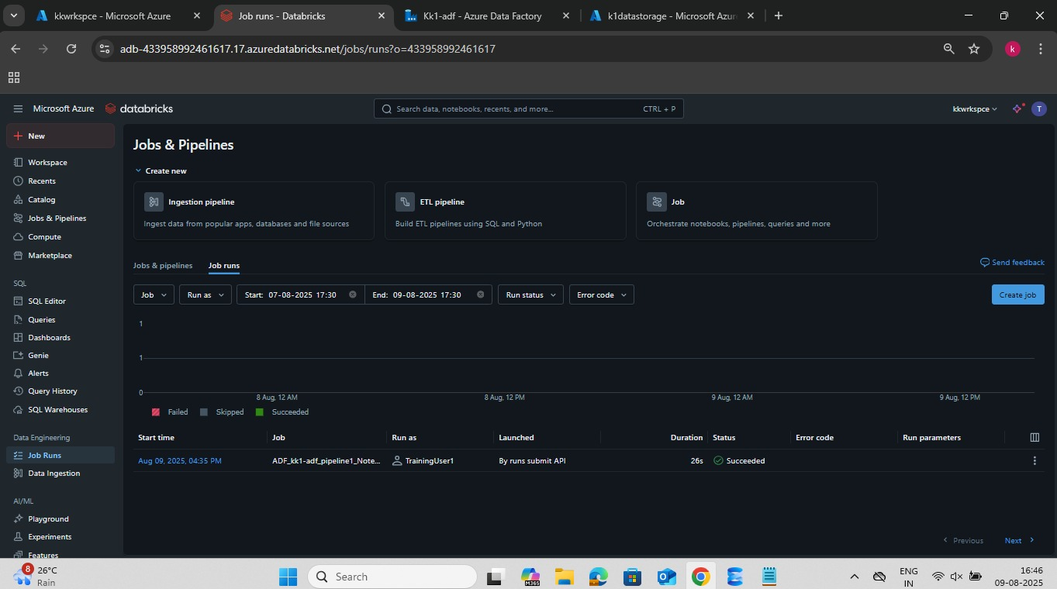

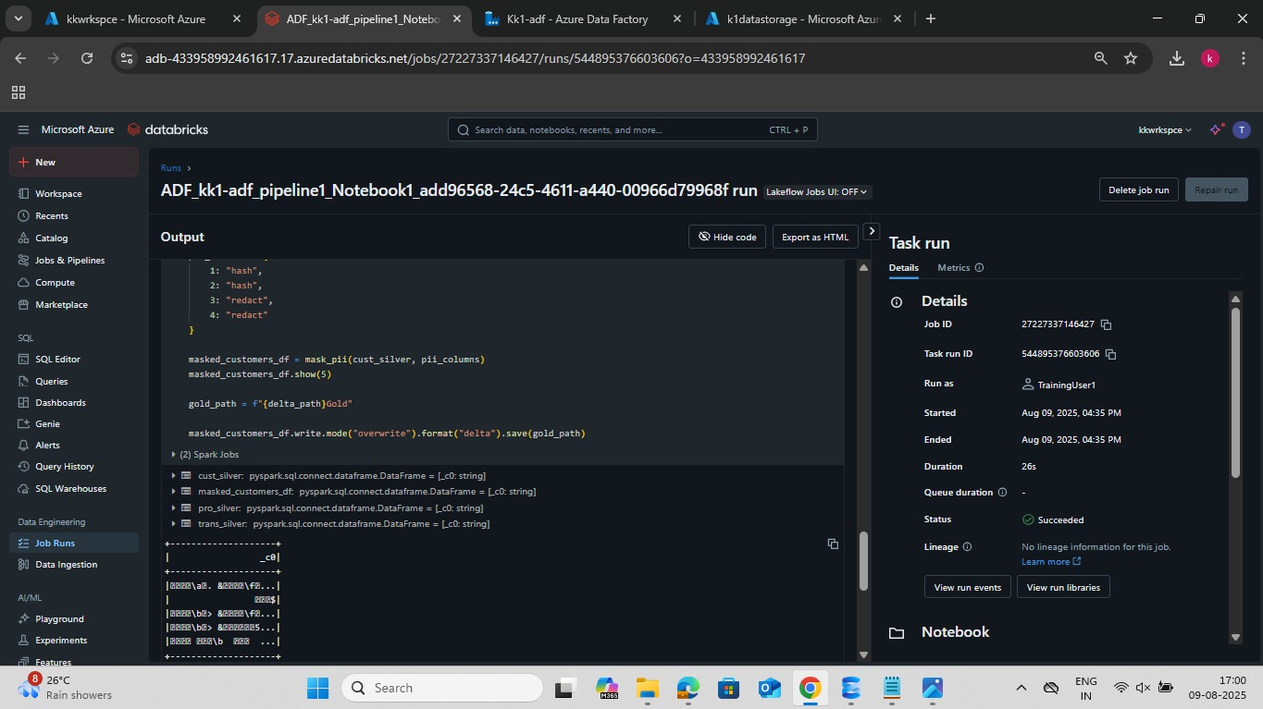

1. Medallion Layers (Bronze-Silver-Gold)

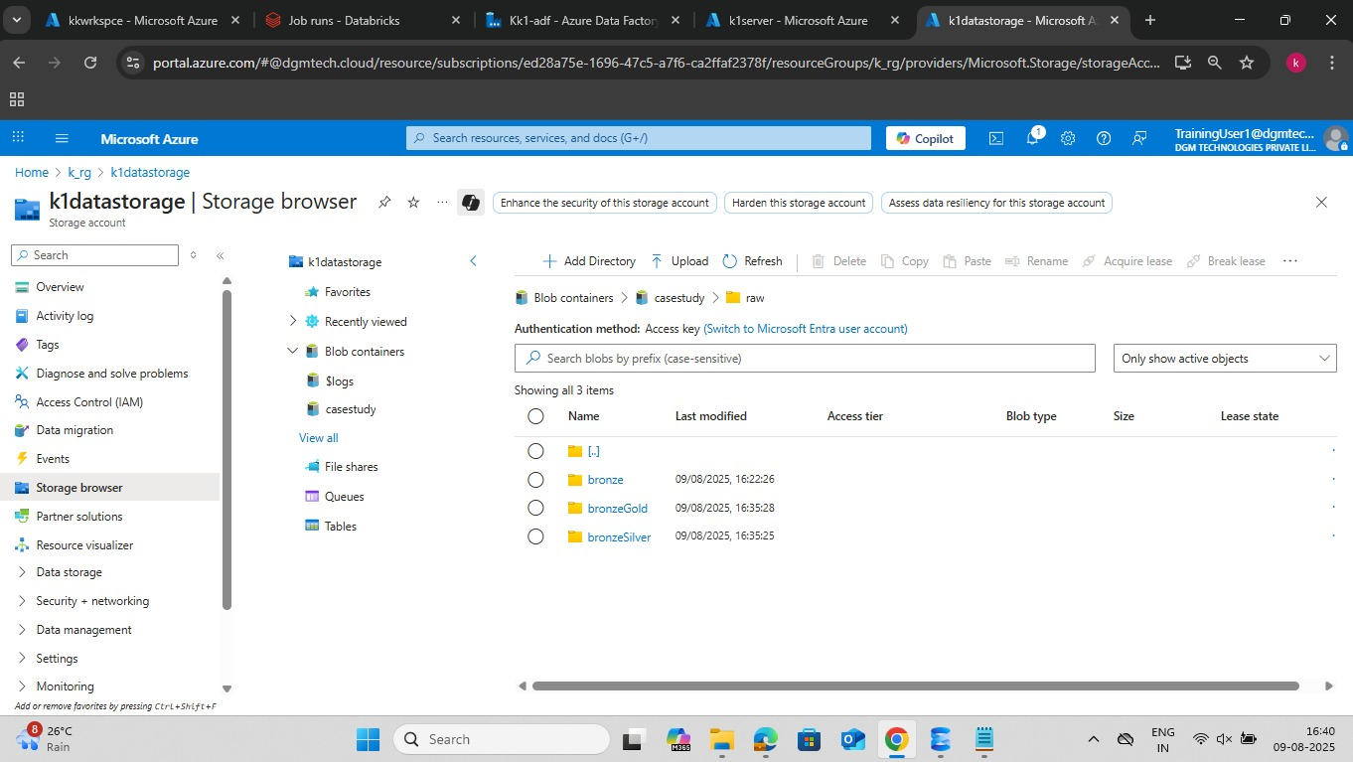

1. Medallion Silver & Gold (Delta logs)

